**Athlete Stop**

Athlete Stop is a website where user can see a lot of sports stuffs. It is an opportunity to have an idea on what the users are going to buy. This is a website that user can sign up or log in in order to buy things they want. There’s a lot of sports brand partners that the user may be satisfied. The design is not that colorful it consists mostly of black and yellow that may not irritate the users for choosing what they going to order.

In top, user can see their language or citizenship in order to identify the currency of the user. The user can navigate the social medias that the Athlete Stop have. The user can see Facebook page; Twitter account; and Instagram account. Then in the middle part of the website, the user can search products or brands that they going about to see in order to be a convenient website. The user can access his/her account by the account and cart icon where the user can see his/her profile and the transactions.

The website has six (6) navigations where the user can navigate each sections. The user can go to the men’s or women’s section, sports, accessories, brand, and shop. It is very convenient to have this navigation on the website because the user can easily go to the product. It is very important to block all the products that are related to each other.

The main part of the website, the user can easily access the sections by clicking the part they going to see. And also, the featured partner brands that the website has. The user can easily identify the products that the website is selling when there’s a logo of a brand.

To the bottom part, the user can enter his/her email to log in to the website in order to buy and order from the website. And also, in the bottom part, the user can also navigate the social medias that the website has. Then, the user can select the “Find a Store” in order to know where is the near shop or locations that the Athlete Stop have. The user can select the “Contact Us” in order to have contact the store for some inquiries, suggestions, or recommendations. Then, the user can see what’s Athlete Stop all about.

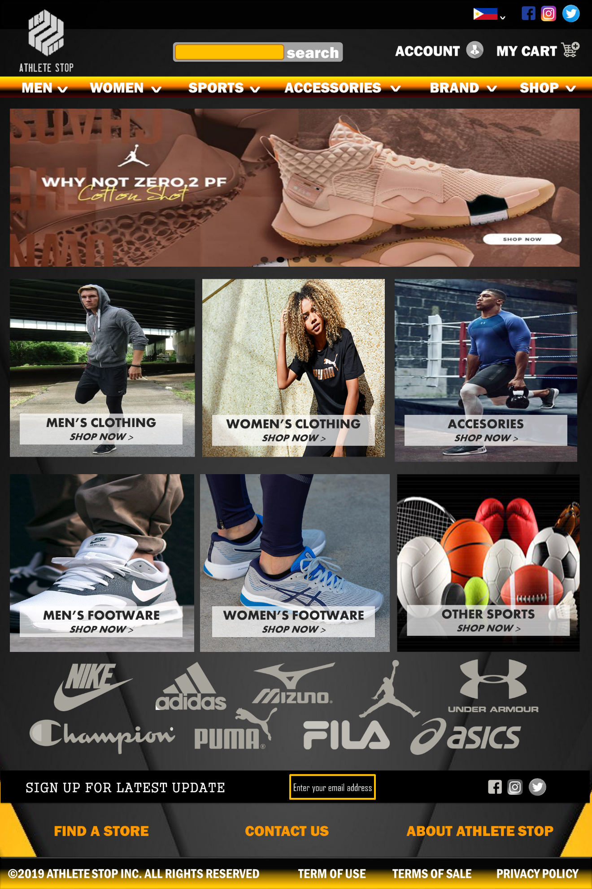

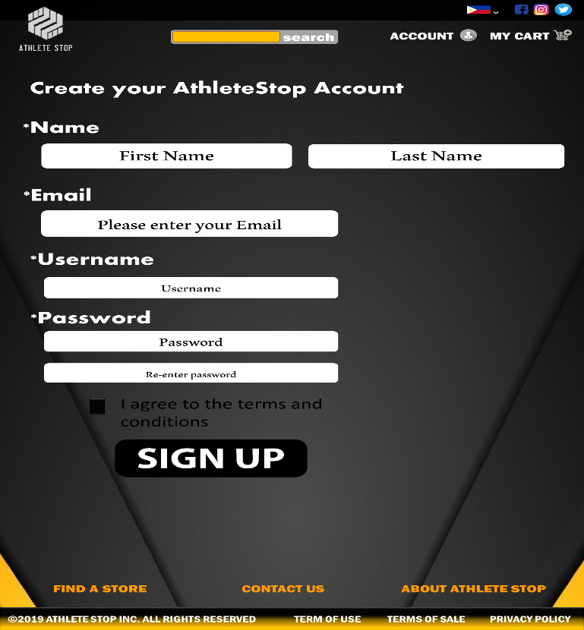

The sign up form enables the user to create his/her account. The design is connected to the homepage which consist the combination of black and yellow with white. The name box identifies the full name of the user in order to know who is the user. The user must enter his/her email in order to send notifications, updates, or to re-cover his/her account. Also, for security, there’s have a password box together with another box in order to verify the password. The user must agree to the terms and conditions of the website in order for the agreement between the user and the website. And lastly, the sign up bottom to proceed to saving the user’s account.